Introduction 2 3 sentences

For this post I will use AD Tool in order to scan small office environments. In this office, company using active directory. this tool provides us vulnerability checking, and more visibility based on attacks.

**Security modeling using AD Tool:**

The ADTool's ease of use is one of its key characteristics. The tool aids the user in creating models that adhere to [18]'s description of the graphical ADTree language. All choices that provide modifying or improving a specific element of a

As shown in Figure 1, right-clicking the node will open the model. Alternatively,

To add, modify, or delete a subtree, simple keyboard shortcuts may be employed.

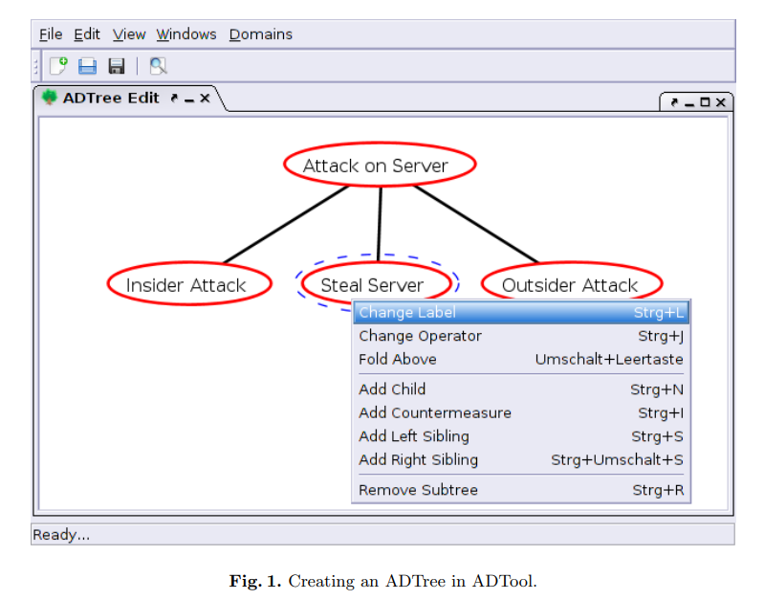

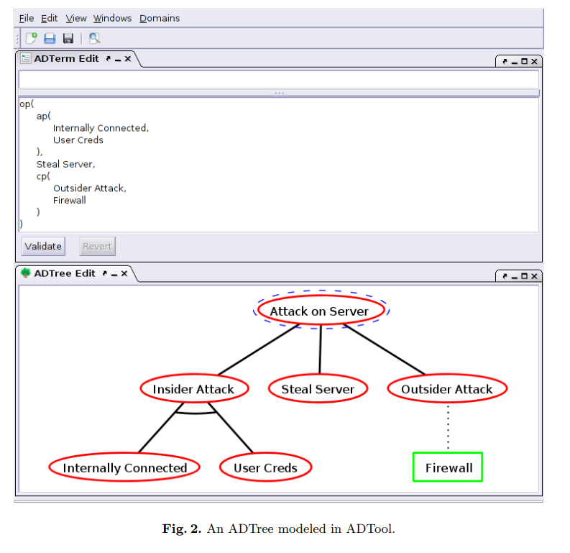

The ADTool also offers sophisticated management and model modification tools. Large models may be analyzed using tools for folding, enlarging, and zooming. By temporarily obscuring certain tree components, users may concentrate on the components that are visible. This is much valued in business meetings and presentations.

ADTrees created with the ADTool may be reused and modified since they can be saved as unique.adt files. Additionally, models may be exported as LATEX files, raster images (png, jpeg), and vector drawings (pdf) (tex). The resulting figures may be used as examples in research papers, presentations for business and industry, and posters. The ability to print trees on a certain number of pages is a specialized option, shown in Figure 3, which improves the readability of large-scale models.

**Reference**

https://arxiv.org/pdf/1305.6829.pdf (Accessed 11th of Aug, 2022)

https://www.researchgate.net/publication/321542879_Quantitative_Evaluation_of_Systems_13th_International_Conference_QEST_2016_Quebec_City_QC_Canada_August_23-25_2016_Proceedings (Accessed 11th of Aug, 2022)

Kordy, B., Kordy, P., Mauw, S., Schweitzer, P.: ADTool: security analysis with

attack–defense trees. In: Joshi, K., Siegle, M., Stoelinga, M., D’Argenio, P.R. (eds.)

QEST 2013. LNCS, vol. 8054, pp. 173–176. Springer, Heidelberg (2013) (Accessed 11th of Aug, 2022)